Collaboration
Creating the Shared Skeleton
Creating the Shared Skeleton 2
Before you Begin 2
Remember, the Main Branch is Sacred! 2
Creating the Skeleton in Visual Studio 2
Why Are we Doing this? 8
Checking the Configuration 8
Adding the Skeleton to Source Control 10
Adding Other Developers 15
Cloning the Repo in Visual Studio 16
Checking the Clone 17
Last thing 20

Creating the Shared Skeleton

Before you Begin
Make sure that you have completed the work for last week and that you have watched the eLectures for this week before starting this work.

Remember, the Main Branch is Sacred!
In this example we will directly edit a new main branch in a new repo. Under normal circumstances we would not edit the main branch directly!
Why is this, such a big deal?
The code contained in the main branched must always be tested and error free.
If there are any errors in the main branch, then there are two major problems…
- Each system developer will have to work with broken code
- The code in the maser branch is likely to be the code we use for customers, sending out buggy code to customers is not a good idea
One of the times when it is OK to directly edit the main repository is when we are setting it up for the first time.
Usual practice is to create a branch from the main, work on the code in the branch and then when the feature branch is error free we merge it back into the main so the rest of the team has access to the new code.
When we are setting up the main branch for the first time there is no collaboration going on and so it is safe to make global changes to the branch.

Creating the Skeleton in Visual Studio
To carry out work for the module we will create a new solution containing three types of project.
- Test projects
- A class library
- A web-based admin backend

To get started on this work you will need to designate a SCRUM Master who will carry out the initial setting up of the skeleton.
Once the skeleton has been setup as a local copy, the local copy needs to be upload to Git Hub and then downloaded by each team member.
Once each team member has their own local copy of the system they may start working individually on the code.
So, step one as a team you need to designate a SCRUM master.
Work for the SCRUM Master
Clearly the SCRUM master would appreciate the help of their team members for this section, but this work must be completed by one person on one computer. It would be a good idea to form a meeting in Teams so that the designated scrum master is able to share their screen with the other members of the team.
The SCRUM master will need to carry out the following tasks.
Obtain a copy of skeleton.zip from the module web site.
Extract the file and you should see a set of folders and files like so…
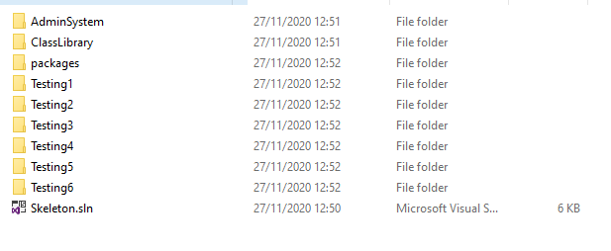
Double click the file Skeleton.sln and this will open the solution with its projects in Visual Studio…
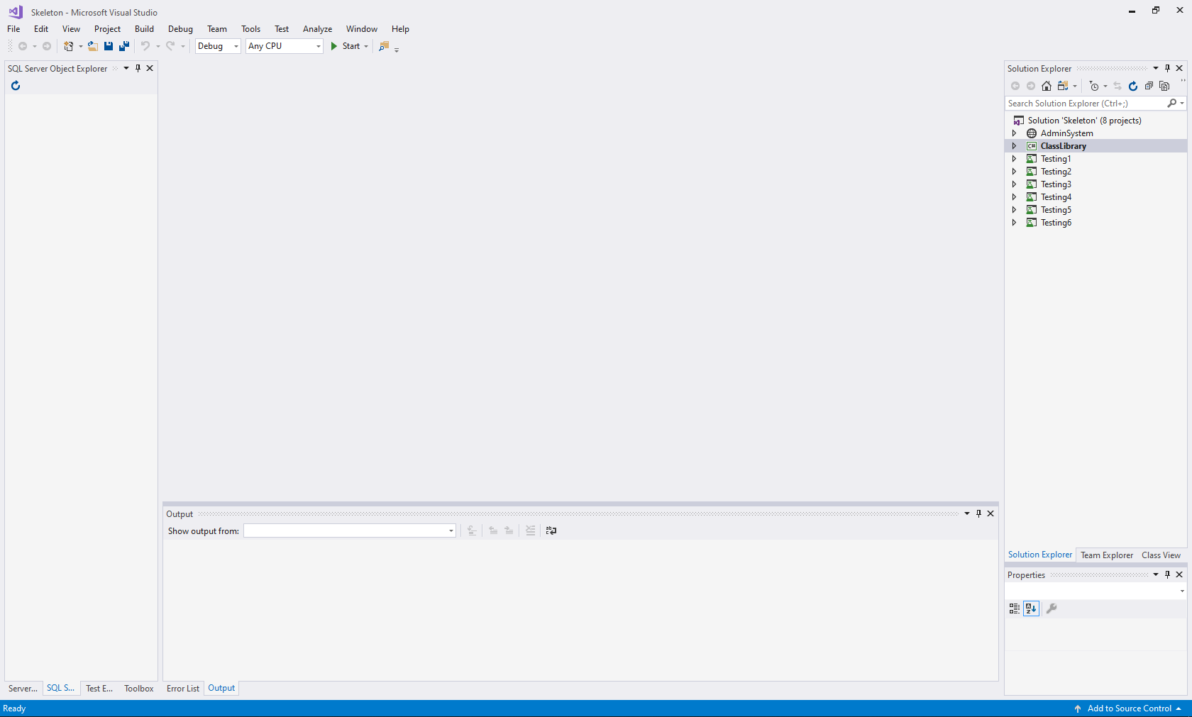
To the right of the interface you will see the projects contained within the solution…
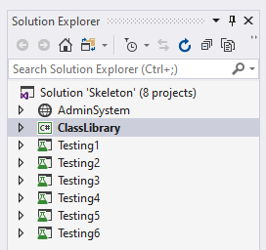
If you click the small triangle to the left of AdminSystem, it will expand the project so you can see all of the files it contains…
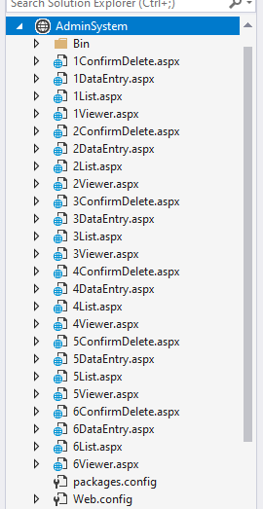
The same is true of the six test projects and the class library…
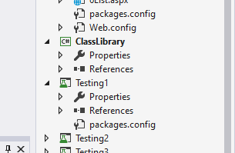
As a team you should have been allocated a section of the system to work on. For example in the imaginary team we looked at last week we had the following…
- Rod Staff management system
Allowing adding, editing, deleting, listing and filtering of staff records
- Jane Customer management system
Allowing adding, editing, deleting, listing and filtering of customer data
- Freddie Stock management system
Allowing for maintenance of stock data, add, edit etc..
- Bungle Order processing
Allowing for customers to input an order and for staff to process that order to dispatch
The first task of the SCRUM Master is to allocate a set of files to each member based on the component.
The simplest way to do this is to number each team member…
- 1. Rod Staff management system
Allowing adding, editing, deleting, listing and filtering of staff records
- 2. Jane Customer management system
Allowing adding, editing, deleting, listing and filtering of customer data
- 3. Freddie Stock management system
Allowing for maintenance of stock data, add, edit etc.
- 4. Bungle Order processing
Allowing for customers to input an order and for staff to process that order to dispatch
So, Bungle is team member 4 so his components in the skeleton will be the following…
From the Admin web site…
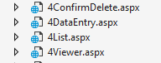
And from the testing projects…
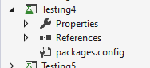
The plan is to rename the number 4 with the name of the Bungle’s allocated component so that they take ownership of those sections of the system.
The SCRUM Master will need to rename each team members allocated files so that it matches their allocated component.
Within the web site each member will take on three files. To rename the files right click on the aspx file and select rename…
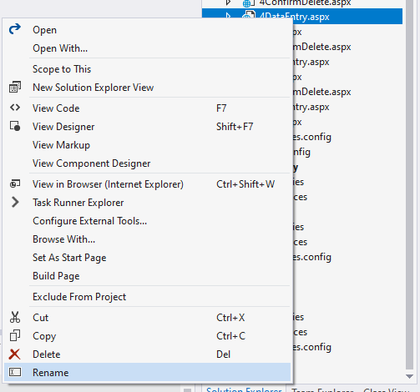
Bungle is working on Order Processing so their file 4DataEntry.aspx will need to be renamed like so…
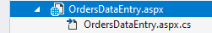
The same for the rest of their web pages marked number 4…
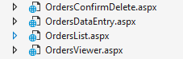
This task will need to be repeated by the SCRUM master for each team member – renaming as appropriate.
A similar task will need to be performed for the test projects. Again, right click and rename to map them to each team members allocated component…
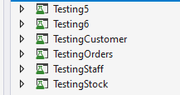
Ignore the components for sections 5 and 6, they may come in useful later.

Why Are we Doing this?
One of the problems with using Git Hub is that it requires a level of skill and knowledge when it comes to resolving conflict in your code.
To reduce the learning curve, we are using a pre-configured solution to reduce the number of potential conflicts as you get to grips with the software. Clearly in the real world you would build the entire system from the ground up.

Checking the Configuration
You should now have a copy of the solution with files and projects allocated to each team member.
To test that all is OK try the following…
Right click on the AdminSystem web site and make it the Start-up project…
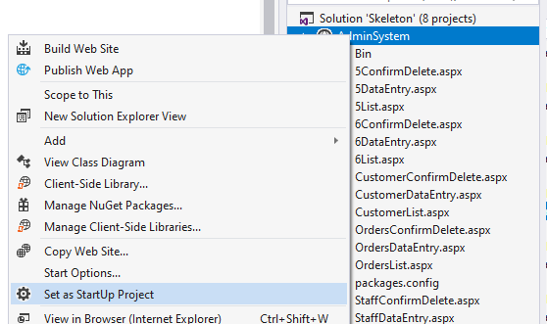

This means that when the program runs it is the web site that starts first rather than one of the test projects.
Next right click on Bungle’s data entry web page OrdersDataEntry.aspx and set this as the start page for the project…
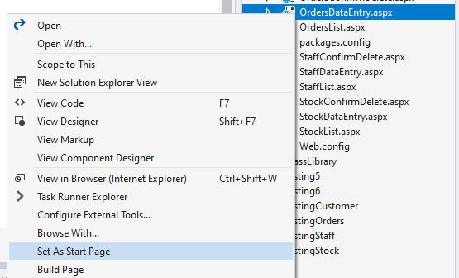
Next type some text into the body of the HTML like so…
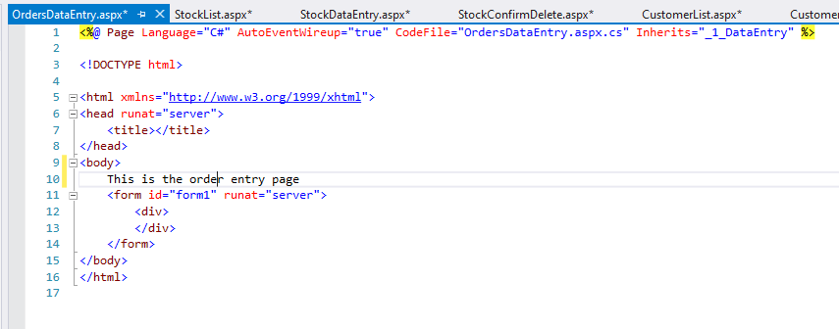
Next press F5 on the keyboard or using the mouse press the play button on the top menu bar, it should display your default browser…
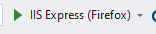
This should run the web site and display this page…
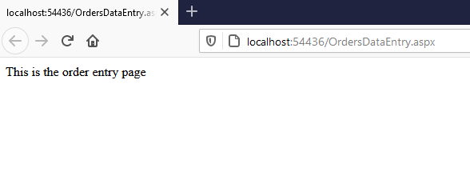
If this works and there are no errors you are now ready to move onto the next stage. (Make sure the program is no longer running by closing the browser or pressing the stop button on the menu bar.)

Adding the Skeleton to Source Control
You now have the main elements of the skeleton completed so we may upload to Git...
Having set up the solution we want to add all the files to source control.
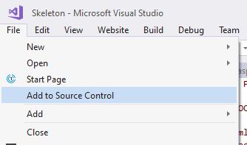
The SCRUM master will need to set up GitHub with a suitable repo to upload the skeleton into the cloud.
From the web interface the SCRUM Master needs to create a new repo...

You could call the repo “Skeleton” but it likely makes more sense to us the name of your entire system e.g. ShoeShop or something…
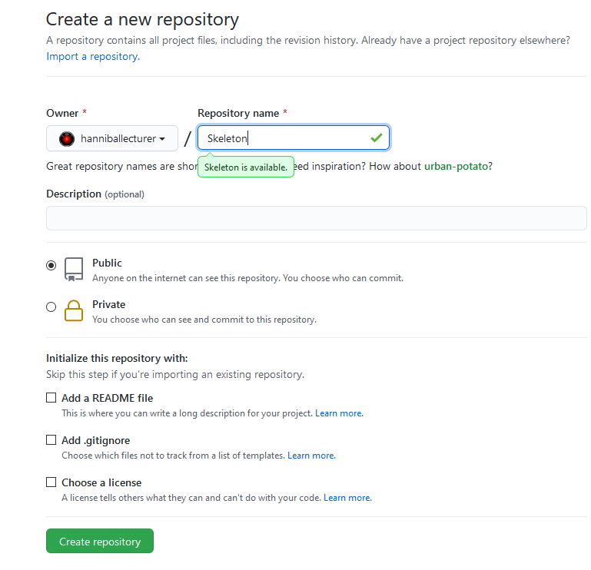
In this example do not initialise the repository with a readme!
Press create repository.
On the next screen, you will see the following…
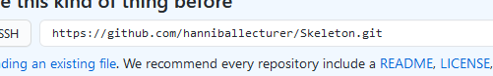
Note the URL that has been given to the repo.
Copy and paste this URL somewhere as you will need it in a moment.
Back over in Visual Studio locate Team Explorer in the bottom right…

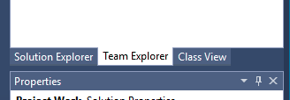
From the home select Synch…
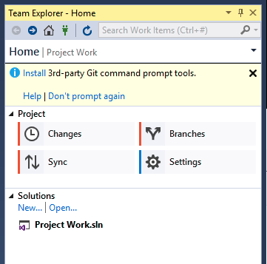

You will then be given a choice of where to publish the repo…
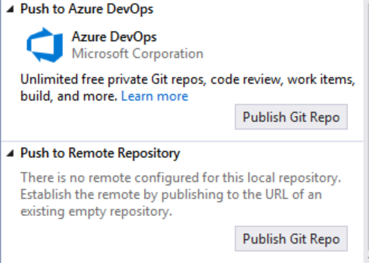

Press Publish Git Repo under the second option “Push to Remote Repository”.
You now need the URL of your repo in Git…
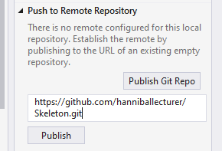

Press publish. It should ask you for your Git user name and password…
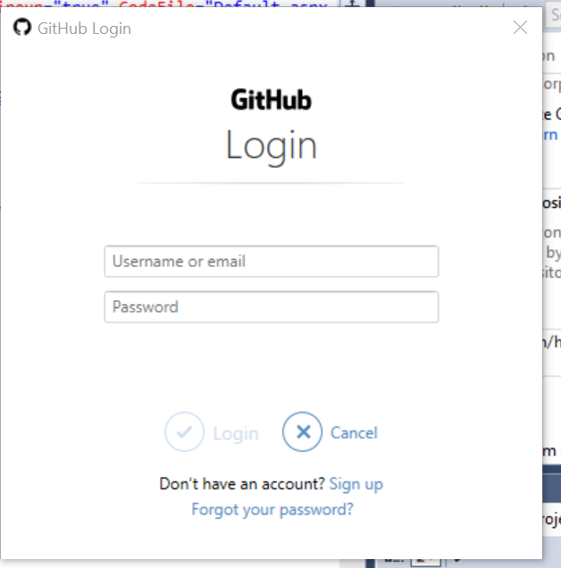
After a few moments you should see a progress bar indicating that the code has been uploaded to Git.
To really check it worked look at the code for the repo from the Git web interface by clicking the repo name at the top of the page…

You should see the following…
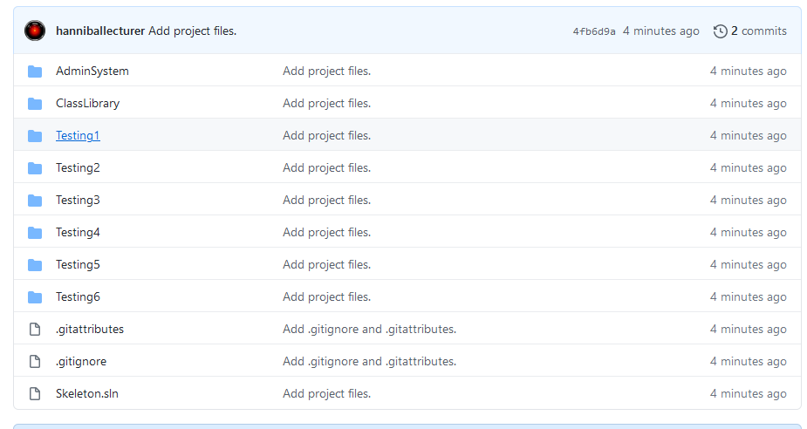
The solution and all of the projects have now been copied to the cloud for sharing with the rest of the team.

Adding Other Developers
This has all been very nice so far, but this is hardly what you would call working as a team.
There is one last thing the SCRUM master needs to do, that is to give the team members access to the repo.
To allow others to work on your code you will need to create a new collaborator.
Under settings find the section for collaborators...
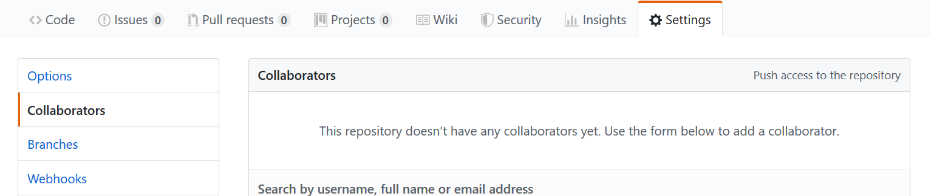

There is a text box here allowing you to search for collaborators...
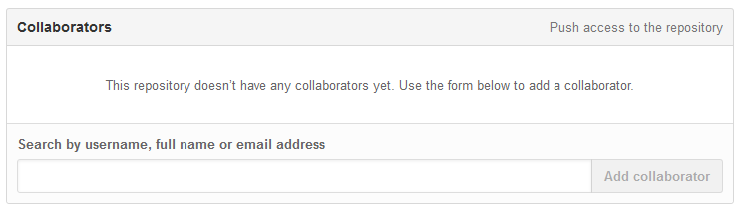
Invitations are sent internally to Git via its own messaging system as well as the person’s email account.
Once you have set up your team with access to the project they will then need to clone the files to their local machine.

Cloning the Repo in Visual Studio
The Scrum Master’s work is now complete for this part of the work and it is down to the team members to create local copies of the solution from the cloud.
Each team member will need a copy of the repository URL.
In VS from Team Explorer select connect and clone…
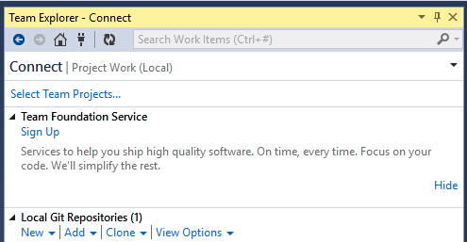
This will allow you to enter the URL for the source and specify a location for the downloaded files.
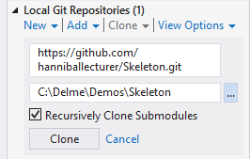
In the local path make sure that you are always cloning into a new empty folder.
Do not clone into a folder which already contains any files as this has the potential to totally break your system
Also make sure it is a path you will be able to find later!
Press clone and all the files will be downloaded locally.

Checking the Clone
If you have got this far and each team member has a clone of the main repository you may check the setup as follows...
Look at the folder structure...
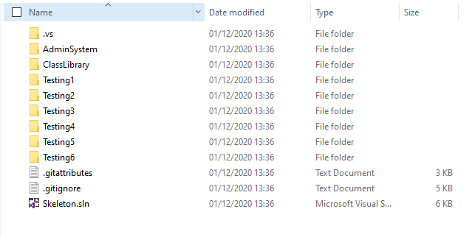
It should be exactly the same for each member of the team. If not, something has gone wrong with the process and you must fix this before continuing.
Again, it should look identical on each team member’s computer.
It is a good idea if each team members tests the configuration to make sure that all is OK.
Try the following…
Right click on the AdminSystem web site and make it the Start-up project…

This means that when the program runs it is the web site that starts first rather than one of the test projects.
Next right clicks on one of your allocated web pages and set this as the start page for the project…
Next type some text into the body of the HTML like so…
Next press F5 on the keyboard or using the mouse press the play button on the top menu bar, it should display your default browser…
This should run the web site and display this page…
If there are any errors at this stage it is important you resolve them with the help of our tutor.

Last thing
All we have done so far is set up the main repository and prove that each team member is able to clone a copy successfully. We are not at the stage yet where, as a team, you may work together to start designing and building the system.

